ASEN 6008: Interplanetary Mission Design Lab
Spring 2016

Lab 5: New Horizon’s Mission Design
Due: Mar. 3, 2016

Name:_____________________________________________

Introduction

This lab will recreate New Horizons’ mission from Earth to Pluto. “New Horizons is the first mission in NASA’s New Frontiers program of medium-class planetary missions. It will be the first spacecraft to visit Pluto [and] Charon.” The spacecraft will also visit Jupiter and potentially several Kuiper Belt objects. The New Horizons mission was designed to encounter Pluto during Pluto’s ecliptic-plane crossing, an event that made the visit possible. However, since Pluto’s ecliptic-plane crossing will occur in the near future, the New Horizons spacecraft needed to attain record-breaking speed to get there in time. On January 19th, 2006, the New Horizons spacecraft became the fastest spacecraft ever constructed by humans. In fact, it only took about nine hours to pass the Moon!

New Horizon’s launch window was small, opening on January 11th, 2006 and closing on February 14th, 2006. A successful launch early in the window would mean that the spacecraft could implement a Jupiter gravity assist (JGA) to accelerate its journey to Pluto. If New Horizons’ launch were delayed past February 2nd, 2006, then the spacecraft would completely miss the JGA opportunity, submitting to a very long deep-space cruise to Pluto. A launch even a week late could mean a delay of up to five years for the Pluto/Charon encounter. Fortunately, the launch occurred early-on in the launch window, allowing the spacecraft to be accelerated by Jupiter enroute.

New Horizons’ mission design timeline is shown in Table 1. In this lab, we will verify that these dates work to provide the spacecraft with a successful mission. We will also evaluate the performance of the Jupiter gravity assist.

Table 1. The mission design of New Horizons’ transfer to Pluto.
Event | Calendar Date | Julian Date
Launch | January 19, 2006 19:00:00 | 2453755.29167
Jupiter Flyby (JGA) | February 28, 2007 05:41:00 | 2454159.73681
Pluto-Charon Encounter | July 14, 2015 11:59:00 | 2457217.99931
Kuiper Belt Objects (KBO) Encounter | 2016 – 2020

The second part of the lab will be to re-design New Horizon’s trajectory had it launched on a different date. In order to do this, we will construct two pork-chop plots: one summarizing the transfer from Earth to Jupiter; the second summarizing the transfer from Jupiter to Pluto. Pluto’s ephemeris coefficients are given in Table 2 (given from JPL’s Solar System Dynamics Page). These aren’t quite as accurate as the other planetary ephemeredes, but they’re good enough.

Table 2. Coefficients for Orbital Elements of Pluto
Orbital Elements | a₀ | a₁ | a₂ | a₃
L (deg) | 238.92903833 | 145.20780515 | 0 | 0
a (AU) | 39.48211675 | -0.00031596 | 0 | 0
e | 0.24882730 | 0.00005170 | 0 | 0
i (deg) | 17.14001206 | 0.00004818 | 0 | 0
Ω (deg) | 110.30393684 | -0.01183482 | 0 | 0
Π (deg) | 224.06891629 | -0.04062942 | 0 | 0

Mission Design Constraints

The New Horizons’ mission designers had the following constraints placed on their trajectory:

- The trajectory should minimize the launch C3 (New Horizons was launched as a very small payload aboard the massive Atlas V rocket!).
- The trajectory should minimize the transfer time.
- The spacecraft must plan on departing Jupiter very soon after it arrives at Jupiter (obvious, but still something to remember during planning).
- Since no maneuvers are performed during the Jupiter flyby, the spacecraft’s incoming hyperbolic velocity must equal its outgoing hyperbolic velocity, that is: |V∞^{in}| = |V∞^{out}|.
- The spacecraft must not impact Jupiter (or one of its moons, rings, etc.).

In this lab, you will have the same constraints while re-creating New Horizons’ trajectory options.
Part I.

In the first part of this lab, we will recreate New Horizons’ actual trajectory.

Problem 1. Use your Lambert code to determine the launch parameters (C3, RLA, DLA) and JGA arrival conditions (V∞^{in,JGA}) using the dates shown in Table 1. Record your answers on the attached Answer Sheet. The following equations will help determine RLA and DLA (Right-Ascension and Declination of the Launch Asymptote with respect to the ecliptic):

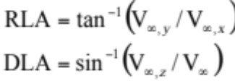

If you’d like to check your answers with a T.A., please do so. We want your code working well.

Problem 2. Use your Lambert code to determine the JGA departure conditions (V∞^{out,JGA}) and Pluto/Charon arrival conditions (V∞^{in,P}) using the dates shown in Table 1. Record your answers on the attached Answer Sheet.

Problem 3. The values of |V∞^{in,JGA}| and |V∞^{out,JGA}| should be identical. Why? How close are these values given the dates and our code? What might have caused the observed differences?

Problem 4. Use your gravity-flyby code to determine the B-Plane parameters, turn angle, and altitude of closest approach with Jupiter for the Jupiter Gravity Assist. Assume that Jupiter’s radius is 71,492 km and its gravitational parameter is μ_{J} = 1.268 x 10⁸ km³/s² (Vallado). Record your answers on the attached Answer Sheet.

Problem 5. What is the Heliocentric ΔV provided by the Jupiter gravity assist?

Part II.

Pork Chop Plots

Construct two pork chop plots and include them when you turn in your lab:
- A plot showing the available trajectories between the Launch and the JGA. Set the time boundaries to be equal to the values shown in Table 3. Include contours of the launch C3, the arrival V∞, and the time of transfer.
- A plot showing the available trajectories between the JGA and Pluto/Charon Arrival. Set the time boundaries to be equal to the values shown in Table 3. Include contours of the departure V∞, the arrival V∞, and the time of transfer. Note!! We’re not plotting C3 this time!

Table 3. The time boundaries for the two New Horizons pork chop plots.
Pork Chop Plot | Variable | Value
Launch – JGA | Starting Departure Date | 2453714.5
 | Ending Departure Date | 2453794.5
 | Starting Arrival Date | 2454129.5
 | Ending Arrival Date | 2454239.5
JGA – P/C Arrival | Starting Departure Date | 2454129.5
 | Ending Departure Date | 2454239.5
 | Starting Arrival Date | 2456917.5
 | Ending Arrival Date | 2457517.5

The first pork chop plot will look pretty normal; the second will look different from a typical pork chop plot. The main reason that it looks different is because a gravity flyby does not need to minimize V∞ and thus we’re looking at a different region of the plot.

Mission designers may identify candidate gravity swingbys using these pork chop plots. A candidate swingby is a swingby that meets the following criteria:

- The departure date is roughly equal to the arrival date
- The |V∞^{out}| ≈ |V∞^{in}|

This means that if you launch on a certain day and arrive at Jupiter on a certain day, then for the gravity swingby to work, you must depart Jupiter on that day with the same |V∞|. For the time being, we are not going to concern ourselves with whether or not the swingby impacts the planet (that’s next).

Problem 6. Construct a program that searches these two pork chop plots and identifies candidate trajectories with valid gravity swingbys. The candidate trajectories must meet the following requirements:

- They must depart Earth on January 9th, 2006 (10 days prior to New Horizons’ actual launch)
- They must depart Earth with a C3 value no larger than 180 km²/s² (this is probably a bit high, but we’ll work with it).
- They must pass by Jupiter sometime in the window given in Table 3.
- They must depart Jupiter within 0.1 days of the Jupiter arrival (it’s easiest just to set them equal).
- The value of |V∞^{out}| must be within 0.4 km/s of the value of |V∞^{in}|; the closer they are to each other the better. Begin with the 0.4 km/s requirement – then, once you have this working, feel free to reduce this down to 0.1 or 0.01 km/s or otherwise as small as possible.
- They must encounter Pluto/Charon sometime in the window given in Table 3.
- The value of |V∞^{in,P}| must be no larger than 14.5 km/s. The notion is that if the spacecraft is moving any faster, there won’t be enough time to do proper science during the flyby!

Recommendations: Make sure your pork chop plots have high-enough resolution to produce successful trajectories – but if the resolution is too high, it will take much too long to search through the data! Perhaps you can narrow your search space somehow.

Answer the following questions on the attached Answer Sheet.

Question 6a. Given a launch date of 1/9/2006 and all of the constraints listed above, what is the smallest value of C3 that could be used to reach Pluto/Charon using an acceptable Jupiter gravity assist? Hint: the value should be in the ballpark of 150 – 180 km²/s².

Question 6b. Given the same constraints, what is the earliest date that a spacecraft could reach Pluto/Charon using an acceptable Jupiter gravity assist? You should find that this date is heavily dependent on Req. #5 and #7.

Question 6c. Given the same constraints, what is the smallest value of |V∞^{in,P}| that may be obtained using an acceptable Jupiter gravity assist?

Question 6d. Given the same constraints, what do you think would be an optimal trajectory to visit Pluto using a Jupiter gravity assist? How does this compare with New Horizons’ actual trajectory? Please provide the C3 value, the JGA date, the difference in V∞^{out}| and |V∞^{in}| at Jupiter, the Pluto/Charon arrival date, and the value of |V∞^{in,P}|.

Part III.

Impact Considerations

The last major constraint for a successful gravity swingby trajectory is to ensure that the trajectory does not impact the planet during the swingby (or one of its moons / rings / radiation / etc.). Mission designers take the candidate gravity swingbys (those that were produced in Question 6) and then test to see how close they get to the host planet. If they impact the planet, or come too close, then they are discarded.

For the purposes of this lab, the spacecraft may not come any closer than 30 R_{J} (2,144,760 km) from the surface of Jupiter (is this reasonable? Why/why not? Just a thought exercise, you don’t have to write anything about this.).

Answer the following questions on the attached Answer Sheet.

Question 7a. Given a launch date of 1/9/2006 and all of the constraints listed above including the gravity-flyby-distance constraint, what is the smallest value of C3 that could be used to reach Pluto/Charon using an acceptable Jupiter gravity assist?

Question 7b. Given the same constraints, what is the earliest date that a spacecraft could reach Pluto/Charon using an acceptable Jupiter gravity assist?

Question 7c. Given the same constraints, what is the smallest value of |V∞^{in,P}| that may be obtained using an acceptable Jupiter gravity assist?

Question 7d. Given the same constraints, what do you think would be an optimal trajectory to visit Pluto using a Jupiter gravity assist? How does this compare with New Horizons’ actual trajectory? Please provide the C3 value, the JGA date, the Pluto/Charon arrival date, and the value of |V∞^{in,P}|.

Final Note: Would your code work if we had to patch together three or more pork chop plots, instead of just two? Is it scalable? Is it clear and streamlined? These things will be important for the final project. Please keep them in mind!

Extra Credit (worth a maximum of 10 pts): Plot the trajectory you identified in Question 7d using Matlab or some other plotting routine. A two-body model of the trajectory is sufficient to see the overall structure of the trajectory. The figure shown below provides an example trajectory – actually, it shows New Horizons’ actual trajectory.

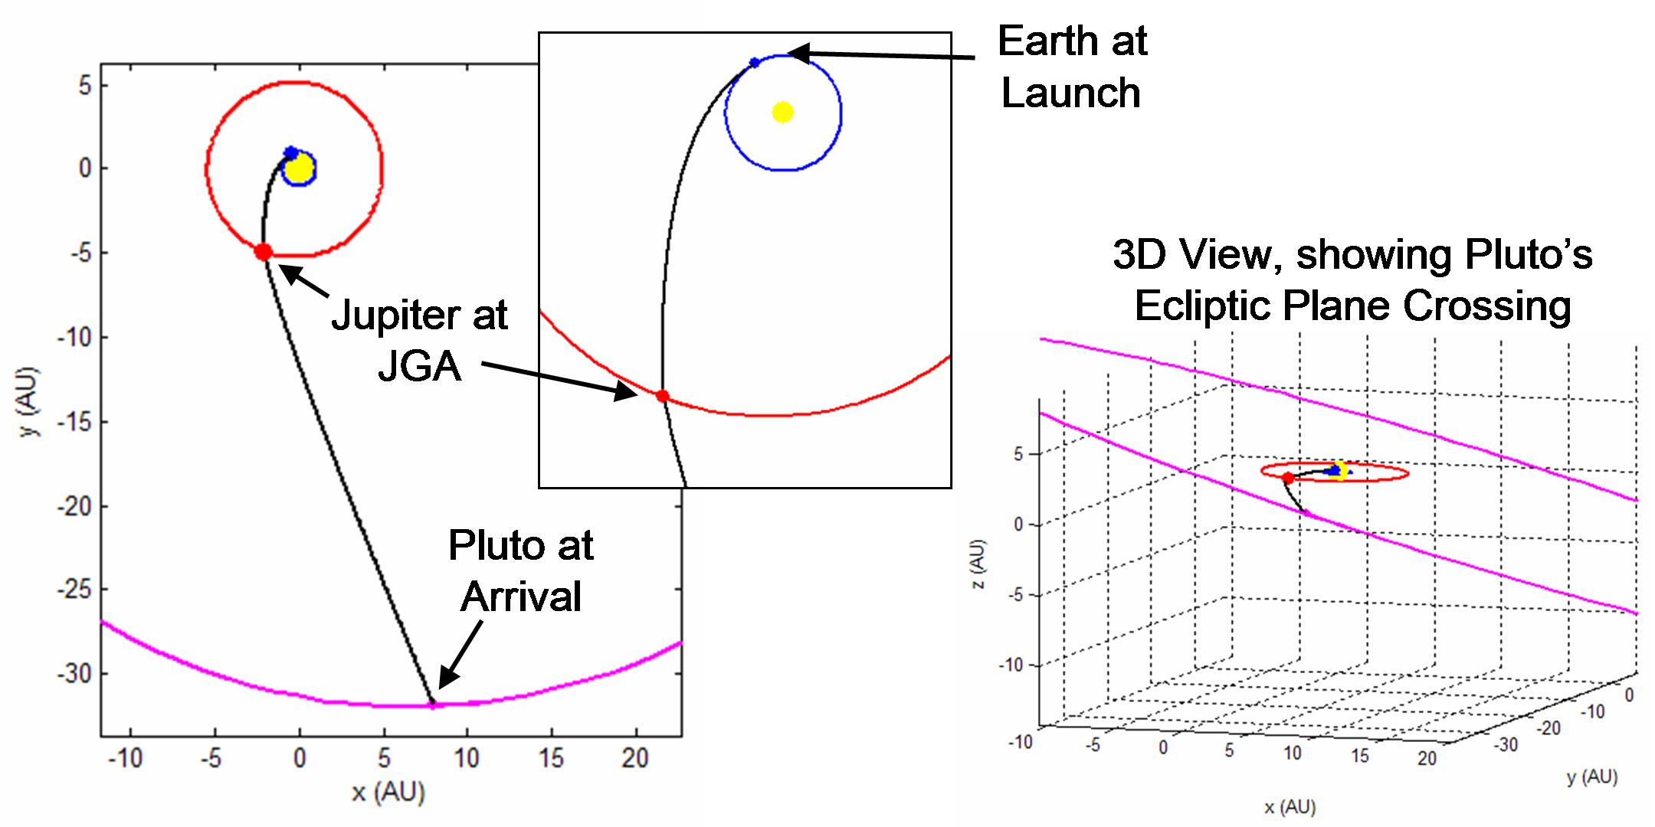

Lab 5: New Horizon’s Mission Design
Due: Mar. 3

Answer Sheet

Name:________John Clouse_________________________________ _____/132

NOTE: PLEASE give all answers in Julian Dates or Calendar Dates (i.e. Jan 1, 2010)

Part I.

Problem 1.

C3: 165.5 km^2/s^2 (3 pts)

RLA: -146.85 deg (3 pts)

DLA: 3.03 deg (3 pts)

|V∞^{in,JGA}|: 19.09 km/s (3 pts)

Problem 2.

|V∞^{out,JGA}|: 18.61 km/s (3 pts)

|V∞^{in,P}|: 14.14 km/s (3 pts)

Problem 3.

Why should the values of |V∞^{in,JGA}| and |V∞^{out,JGA}| be identical? (5 pts)
They should be the same because no propulsive maneuvering is performed, thus energy should be the same, and the velocities at SOI should be the same. I'm about 0.5 km/s off.

How close are they using these dates and your code? 0.5 km/s (1 pt)

What might have caused the observed differences? (5 pts)
I believe assumption about Jupiter not moving may be playing a role, as well as 3rd-body effects of Jupiter on the heliocentric spacecraft, and possibly some error in the ephemeris calculation.

Problem 4.

B_{T}: 2.478446e+06 km (3 pts)

B_{R}: 2.531541e+05 km (3 pts)

Turn Angle: 15.9 deg (3 pts)

h_{p}: 2.09599e+06 km (3 pts)

Problem 5.

ΔV: 5.28 km/s (3 pts)

Pork Chop Plots:

Launch – JGA: (20 pts)

(Please attach to this Answer Sheet)

JGA – Pluto/Charon: (20 pts)

(Please attach)

Candidate Gravity Swingbys:

6a: C3: 153 km^2/s^2 (3 pts)

6b: Pluto/Charon Arrival Date: May 6, 2015 (3 pts)
(Please write this date as a JD or as a standard, readable date, i.e., Jan. 9th, 2006)

6c: |V∞^{in,P}|: 12.74 km/s (3 pts)

6d: (10 pts)
C3: 162 km^2/s^2 .

6d: JGA Date: March 8, 2007 .

6d: V∞^{out}| and |V∞^{in}|: 17.9036 and 17.9040________________________

Pluto/Charon Arrival Date: April 22, 2016 .

6d: |V∞^{in,P}|: 12.82 km/s .

How does this compare with New Horizons’? Is it better? What do you think? (10 pts)
I think it's a little better in terms of passing by the target more slowly, so more science can be done. However, this sacrificed speed might make it less capable of passing Kuiper Belt Objects of interest.

Impact Considerations:

7a: C3: 153 km^2/s^2 (3 pts)

7b: Pluto/Charon Arrival Date: May 6, 2015 (3 pts)
(Please write this date as a JD or as a standard, readable date, i.e., Jan. 9th, 2006)

7c: |V∞^{in,P}|: 12.74 km/s (3 pts)

7d: (10 pts)
C3: 162 km^2/s^2 .

7d: JGA Date: March 8, 2007 .

7d: Pluto/Charon Arrival Date: April 22, 2016 .

7d: |V∞^{in,P}|: 12.82 km/s .

Extra Credit (10 pts)

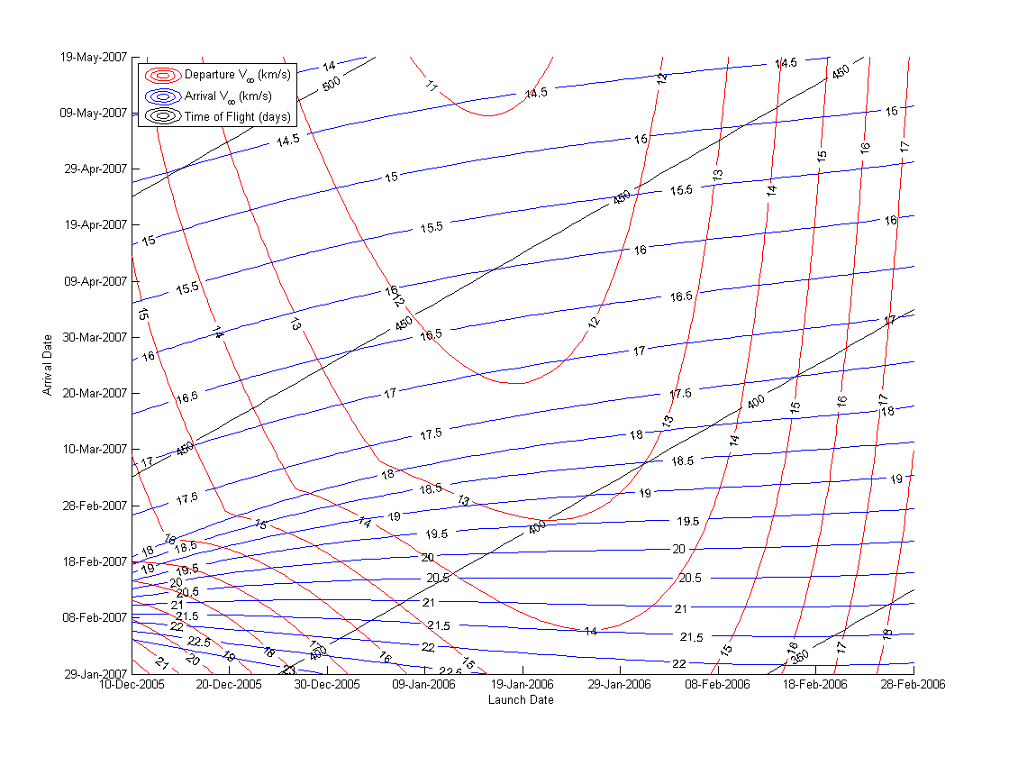
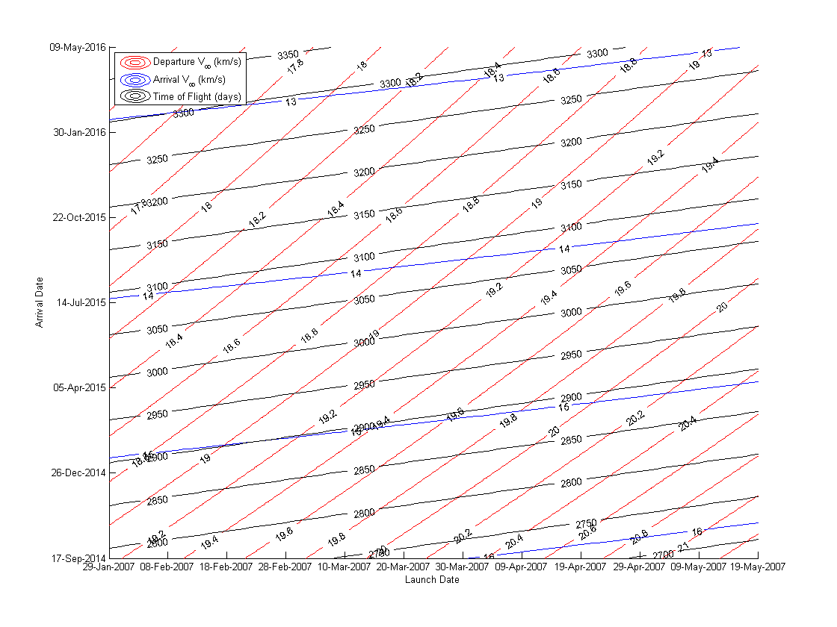

NASA’s New Horizon’s Home Page: http://www.nasa.gov/mission_pages/newhorizons/main/index.html, 10/2006.
Johns Hopkins University / Applied Physics Laboratory / New Horizon’s Home Page: http://pluto.jhuapl.edu/, 10/2006.

